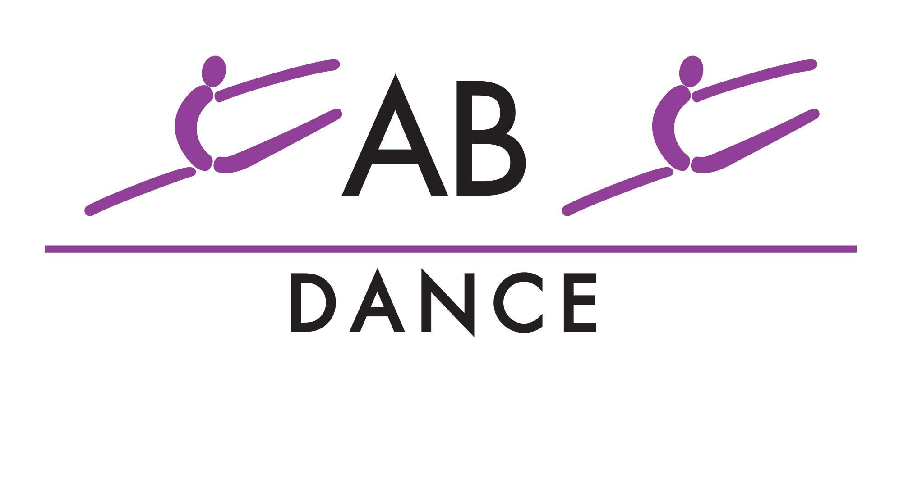
Summer Competitive Intensives
REGISTER

Ballet Intensive With Sheona Bell

Dates: Saturday June 6th Fee: $50

5:30-7:00 - Age 7-11
7:00-8:30 - Age 12-17

June – 3 Day Technique Intensive with Christianna
Dates: Saturday June 13 – Tuesday June 16 Fee: $125
Mini
Sat & Sun: 12:00–2:00 Mon: 4:30–6:30
Junior
Sat & Sun: 2:00–4:00 Mon: 6:30–8:30
Inter / Teen
Sat & Sun: 4:00–6:00 Tue: 4:30–6:30
Senior
Sat & Sun: 6:00–8:00 Tue: 6:30–9:30
July – 4 Day Technique Intensive with Christianna
Dates: Wednesday July 29 – Saturday August 1
Mini: 10:00–12:00 — $160
Junior:12:00–3:00 — $240
Inter / Teen: 3:30–6:30 — $240
Senior: 6:30–9:30 — $240
July – 3 Day Technique Intensive with Maeve
Dates: Wednesday July 22 – Friday July 24 Price - $90
MINI - 4:00-5:00 ($50) Junior - 5:00-6:30, Inter/Teen 6:30-8:00, Senior 8:00-10:00

August - Acro Intensive With Christianna

Dates: Wednesday August 19th - Thursday August 20th
Price - $60 (Mini) $80 (Junior-Senior)

Teens - 2:00-4:00
Mini - 4:00-5:30
Junior - 5:30-7:30
Inter/Senior - 7:30-9:30

August – Competitive Team Bootcamp
Dates: Monday August 24 – Thursday August 27 Fee: $300
Mini & Junior: 10:00-2:00 Inter & Teen: 2:00-6:00 Senior: 6:00-10:00

